PhD student research and learning program
(MIN: 2-3 pages; MAX: 6-7 pages)

Doctoral student:

Reference period:

Supervisor(s):

Research title:

SDGs Goal(s) (include also the image(s) like 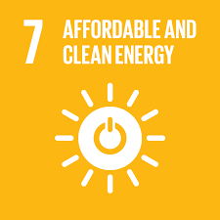 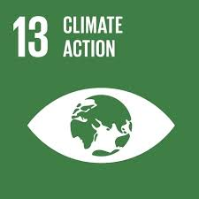 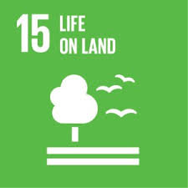)
The icons are available at: https://www.un.org/sustainabledevelopment/news/communications-material/

Targets (for example: 15.4 “By 2030, ensure the conservation of mountain ecosystems, including their biodiversity, in order to enhance their capacity to provide benefits that are essential for sustainable development”; you don’t need to report the full text of the target, but only the number. For the official list of targets: https://unstats.un.org/sdgs/indicators/indicators-list/ )

Research project presentation
(see the manual “research synopsis writing”) available in http://www.tesaf.unipd.it/en/research/doctoral-degrees-phd-lerh-program/documents

Abstract

1. Background and justification

2. Research questions

3. General and specific research objectives

4. Research methodology

Materials and methods: location of study area, sources of primary and secondary information, data elaboration, SW, expected outcomes, risk and ethics of proposed research,…

5. Time schedule

6. References

Learning program and other information

7. Learning activities (courses of the 1st year)

8. Planned staying abroad required to meet the research objectives (indicative)

9. Previous research experiences and related publications

PhD_student_research_learning_program.docx

