Allegato 11 – Estratto Annex 1 – Project proposal (Decreto Direttoriale n. 1032 del 17-06-2022)
- SCIENTIFIC QUALITY
  - Research programme
    - Relevance, motivation and characteristic
The European Green Deal (COM2019 640 final), an essential part of the United Nations 2030 Agenda implementation, sets ambitious goals for the economy and especially for the agricultural sector, aiming to preserve the stock of natural capital and to achieve climate neutrality by 2050. To achieve these objectives, the document emphasizes the importance of digital technologies, highlighting the key-role of the agri-food sector and the importance of the Farm to Fork strategy as operational tool to implement the Green Deal in the agricultural sector. Coherently with this perspective, in the recently published report of the 5th SCAR (European Commission's Standing Committee on Agricultural Research) ("Resilience and transformation"), three main key goals are identified:
  - Ensuring nutritious, healthy and sustainable food for all
  - Setting up full circularity of food and agricultural systems
  - Restoring diversity in our food, farm and social systems
How to shape future agricultural and rural systems to obtain a safe operating space is becoming a key-question for researchers and policy makers. Knowledge and innovation are identified as priority tools for achieving these goals.
Producing sufficient and safe food for a growing population without over-exploiting natural resources is one of the major problems that our society must face, finding solutions which are sustainable in the long term. This is a global challenge, placed in a difficult context of unstable climate, increasing competition for land, water and energy, in an increasingly urbanized and globalized world. The importance and the breadth of this challenge requires a significant research effort that is far beyond the capacity of any single institution. To adequately address this issue, it is mandatory to develop an integrated, large-scale, multi-disciplinary research programme.
This is the ambition of Agritech partners, which, by building upon pre-existing collaborative research, higher education initiatives, networking of infrastructures and large equipment sharing, have defined a programme motivated by the need to:
- Combine the top research expertise required to adequately address in a truly multidisciplinary context the multifaceted problems associated with sustainable agriculture.
- Integrate the research infrastructures and equipment available at each site.
- Exploit and apply the most suitable Key Enabling Technologies (KET) that can allow a profitable advance in productivity, sustainability, ecological and digital transition in the agricultural sector.
- Work with companies and farmers to co-design research efforts and exploit at the best the results to increase the resilience and economic competitiveness of agri-food supply chains.
- Develop and disseminate new models and organizational capabilities to create and implement large- scale, strategic research programmes that cross discipline boundaries and industrial sectors.
- Train the next generation of Agritech scientists and managers to generate the necessary human capital and skills required.
- Support policy makers and influence public opinion to promote a social context favoring the development of stable and equitable agri-food supply chains.
The main characteristic of Agritech research programme is its structural organization, which reflects the high level of integration among a broad diversity of participating research institutions and companies. Indeed, we have created national spokes focused on cutting-edge thematic areas, which are anchored into a central hub to form a cross-linked network supporting, at the same time, a focused approach, and the necessary interactions among different areas to enhance the overall impact of Agritech. The multidisciplinary environment within each spoke naturally generates functional links with other spokes that will allow the development of a coordinated and highly integrated research programme, required to address the complex and ambitious Agritech objectives.

    - Objectives
The Ministry of University and Research (MUR) has clearly indicated the strategic impact and the main areas of research needs for the Research Center in Technologies for Agriculture, first in the Guidelines for the System Initiatives of Mission 4 Component 2, published on October 7th 2021, and then in the Annex A of the Call for the National Centers, published on December 17th 2021. Based on the research needs and expected impact declared in the above documents, upon accurate analysis of the most challenging current and future demands of the agricultural sector, in terms of overall increase in productivity to address food security needs and reduce the environmental impact, under changing climatic conditions, and considering the current and future availability of enabling technologies, we identified five general research objectives for Agritech Center:

I -Resilience: Enhancing sustainable productivity and promoting resilience to climatic changes II-Low impact: Reducing wastage and environmental impact
III-Circular: Development of circular economy strategies IV-Recovery: Sustainable development of marginal areas
V-Traceability: Promoting safety, traceability and typical traits in agri-food chains
An analysis of the current state-of-the-art of Italian research in agriculture clearly indicates a consolidated track record of activities aiming to enhance crop yield, quality and sustainability of production strategies, as can be easily inferred by the publications produced in the last 6 years (see section A1.3). These are the key- elements on which the Italian scientific community will build upon to face the big challenges outlined in the previous section, through the development of tailored new materials and production strategies meeting at the best the constraints imposed by the unstable climatic conditions, and by the specific ecological and socio- economic requirements of different geographic areas. These are the major gaps to fill, starting from a well- established tradition of scientific research. The use of cutting-edge technologies will be implemented at all levels, to foster the digitalization and de-carbonization of the green transition of agriculture, but always taking into consideration the protection of the typical traits of agri-food products, and the certification of their quality and of the ecological sustainability of the production process.
In our vision, the general objectives outlined above can be achieved by allocating Agritech research efforts on 9 different strategic thematic areas, that will be the domains of investigation and exploitation of 9 different spokes:

- - Plant, animal and microbial genetic resources and adaptation to climatic changes
- - Crop Health: a multidisciplinary system approach to reduce the use of agrochemicals
- - Enabling technologies and sustainable strategies for the smart management of agricultural systems and their environmental impact
- - Multifunctional and resilient agriculture and forestry systems for the mitigation of climate change risks
- - Sustainable productivity and mitigation of environmental impact in livestock systems
- - Management models to promote sustainability and resilience of agricultural systems
- - Integrated models for the development of marginal areas to promote multifunctional production systems enhancing agroecological and socio-economic sustainability
- - New models of circular economy in agriculture through waste valorization and recycling
- - New technologies and methodologies for traceability, quality, safety, measurements and certifications to enhance the value and protect the typical traits in agri-food chains
Research and innovation efforts in each of the above strategic thematic areas are intended to address one or more general objectives as hereafter schematically reported (Figure A1).

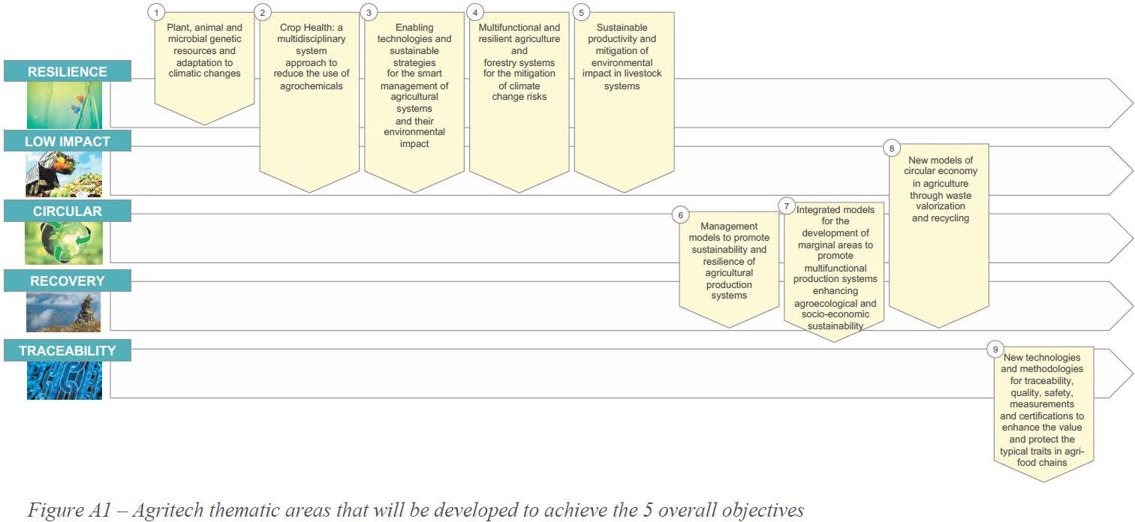

    - Research activity and methodology
Agritech research programme is generated by the functional merge of activities planned by the spokes in charge of specific thematic areas.
For each spoke, broad areas of research activity and the relative methodology are hereafter briefly summarized.

- Plant, animal and microbial genetic resources and adaptation to climatic changes
  - Plant, animal and microbial genetic resources: mining for resilience
Resilience of agricultural and forest ecosystems under stressful conditions generated by climate change (CC) requires valorization and exploitation of genetic resources through cutting-edge conservation strategies, combined with deep characterization of genomes and high-throughput phenotyping. Activities will include massive sequencing of accession/breeds/strains, extensive marker-based description of genomes, (pan)genome elucidation, deep phenotyping and multi-omics characterization. Resulting information, processed through advanced methods for complex data analysis/interpretation/storage/management, will highlight superior alleles/haplotypes, identify beneficial interactions under a variety of conditions, and define conservation units.
  - Dissecting morpho-physiological and molecular mechanisms of adaptation
Integrated investigation of variations in epigenomic/transcriptomic/proteomic/metabolomic/volatilomic pools underlying resilience will be coupled with mapping of relevant loci and tailored data analysis. Genes/proteins and molecular/biochemical mechanisms contributing to stress adaptation and improved growth, quality and yield under specific conditions, will be identified. Simulation models will be developed.
  - Developing advanced genotypes with improved resilience
Improved genotypes/varieties/microbial strains will be developed using genetic, biochemical, and multi-omics information. Novel precision breeding technologies and biotechnological approaches (e.g., cisgenesis, genome editing) will allow the design and development of knowledge-based genotypes. Validation of the new genotypes and assessment of potential for varietal development and commercialization will employ smart phenotyping and multi-environment and multi-cultivation system testing. Molecular assays will be developed for distinctness, uniformity and stability (DUS) testing of new varieties and for assessing genetic identity to protect intellectual property rights.

- Crop Health: a multidisciplinary system approach to reduce the use of agrochemicals
  - Agroecology and landscape management to reinforce ecosystem services
Agroecological strategies promoting functional biodiversity, both at farm and landscape level, will be developed to enhance ecosystem services. Environmental monitoring technologies and modeling approaches will allow to assess their impact both on in-crop and off-crop levels of functional biodiversity and their contribution to ecological sustainability.
  - Alternative tools and strategies to reduce the use of synthetic pesticides and fertilizers

Plant defense and nutrition/growth will be reinforced through genetic improvement and enhanced with the use of microorganisms and signaling molecules. Biocontrol agents will be used both as organisms and as source of biopesticides and biostimulants, which will be also obtained from several biomasses; formulation nanotechnologies will allow their safe and efficient delivery. Non- chemical pest control strategies will be developed.
  - Smart technologies towards a sustainable "zero pollution" in agriculture
Accurate environmental monitoring, predictive models for crops, pests and fertilizers management, and precision agriculture will be developed for a timely and targeted environmental delivery of agrochemicals. Deterministic models and artificial intelligence (AI) will drive the definition of Integrated Pest Management plans and fertilization strategies which will be sustainable both from an environmental and socio-economic point of view. A geoSpatial CyberInfrastructure for a Decision Support System (DSS) to reduce the use of agrochemicals and environmental pollution will be developed.

- - Enabling technologies and sustainable strategies for the smart management of agricultural systems and their environmental impact
  - Smart solutions for precise and sustainable management of agricultural systems
A multi-disciplinary approach will be used to develop innovative and crop-specific farming solutions based on automation, AI and data analytics, IoT tools, blockchain, physical and digital models, robots and autonomous vehicles, agro-voltaics, remote and proximal sensing, geospatial techniques. The combined adoption of integrated strategies, including agroecology and low- input/organic agriculture will foster the ecological transition. A portfolio of smart solutions for precision and sustainable agriculture (from sowing/planting to harvesting, through mechanisation, irrigation, fertilization, soil and canopy management, structures and facilities design and monitoring, organization models, energy consumption, etc.) will be developed to be applied in open-field and protected cultivation, including vertical farming.
  - Innovative strategies to protect natural resources and reduce agriculture environmental impact
Strategies for the smart and sustainable use and reuse of water for irrigation as well as for organic carbon and nutrient/fertilizer management, soil carbon conservation and sequestration, and the protection of soil and water quality will be developed and applied. To face drought, pollution, and loss of soil fertility and biodiversity, the research will focus on increasing both the efficiency and sustainability of water and soil use, combining the development of smart technologies (e.g., modelling and forecasting tools, real-time and sensor-based applications, IoT platforms, big data analytics) with the adoption of NBS and ecosystem approaches.
  - Evaluation and demonstration for stakeholder engagement and innovation exploitation
New solutions for smart agricultural systems will be evaluated according to economic, social, and environmental dimensions, supported by advanced strategies for data management and statistical analysis. The innovative solutions developed will be demonstrated at full-scale in real environment and exploited by a coordinated network of living labs, technological platforms, and research infrastructures for the full engagement of society and relevant stakeholders.

- - Multifunctional and resilient agriculture and forestry systems for the mitigation of climate change risks
  - Next-generation technologies for resilient traits of crop varieties and tree species
Integrated and multifunctional solutions will be developed at different scales: (1) at crop level we will exploit next-generation genotyping and phenotyping platforms to predict resilient traits and select cultivated varieties that ensure greater unit yields; (2) at field level we will seek new solutions to boost the input use efficiency; (3) at forest stand level we will identify solutions to increase carbon sequestration, production of high-quality wood for bio-based industry and selection of best options of the wood- supply chain.
  - Smart climate agriculture and forestry: from sustainable products to the bioeconomy
(1) A farm network will be set-up to apply new technologies to save soil, water, carbon-emission and share knowledge according to feedback approaches. (2) A tailored forest management will be developed to maximize climate resilience to biotic/abiotic disturbances. (3) Adaptive agriculture and forestry practices will result from inter- and intra-field variability measurements. (4) Exploitation of ecosystem services and bio-based industry solutions will be finally pursued. High-resolution topography and numerical modeling will support the activities.
  - Integrated climate change risk modelling and management
Activities will develop: (1) an integrated information platform on risks based on climate and remote sensing data, local-scale observatories, soil morphology and quality, land use, natural resources management; (2) an ensemble of models for predicting crop and forest productivity according to plant-environment-resources- technology-farm relationships under different climate

scenarios; (3) strategies on risks management (best practices, insurance, mutuality and credit), agricultural policy and territorial planning. Applications will include AI technologies.

- - Sustainable productivity and mitigation of environmental impact in livestock systems
  - Livestock management for improving resilience to climate change
Advanced strategies allowing livestock systems adapting to climate change will include growing crops resistant to climate constraints, climate smart agriculture, housing, feeding and management, and selection for resilient animals. Technologies developed in the IoT environment, machine learning and artificial intelligence applied to collection and management of complex data sources (e.g. climate, animal health/welfare and performances, -omics) will help in implementing prediction models and producing the tools to guarantee resilience of livestock systems. In this framework, a real time decision support system for breeders will be developed.
  - Smart livestock farming technologies to improve sustainability
A multidisciplinary approach will be adopted to implement strategies mitigating the contribution of livestock systems to climate change, acidification and eutrophication, consumption of natural resources and antibiotic resistance. Such an approach will focus on implementation of technologies for feedstuffs production, genetic selection of less emitting animals, feeding, monitoring animal health/welfare and performances, and for manure management. Life cycle sustainability assessment framework will be implemented for assessing the overall sustainability of livestock systems through Life Cycle Assessment (LCA), Life Cycle Costing, and Social LCA. Strategies will include those, which may increase the benefit for the environment (ecosystem services) when animals are integrated into agroeco/food systems.

- - Management models to promote sustainability and resilience of agricultural systems
  - Farm management models to enhance sustainability and resilience from intensive to marginal areas
New management models for next generation agriculture will be developed for agroecosystems in intensive and in marginal areas. Once validated, KET and new smart and multifunctional solutions will be adopted for reducing external inputs and improving productivity, health, quality and safety of crops. Innovative data management and AI techniques will create new DSS to guide farm management to more efficient use of nutrients, soil, water and energy resources. Indicators will describe the enhanced global value of new agri- food, no-food, forest and animal production chains.
  - Circular management models to recover and enhance value of waste materials
New circular valorization farm models upcycling biowastes will be developed. Combination of technologies to produce energy and biofertilizers, soil amendments, biostimulants, biopesticides, green feeds, insect-based feeds will be optimized. Calibration and application in agriculture of recycled products will be fine-tuned and, through LCA analysis, eco-planning and design thinking, circular models will be developed combining different farm types, food and feed companies with waste transformation plans.
  - Socio-economic and cultural models to link farm production to consumer expectations
Socio-economic models will be optimized promoting the connection of the new agricultural solutions to industry, new policies with business models, global market with local communities and conversely upstream, consumer vision to farm management. Communication and formation programs will be addressed to foster human capital for the development of new enterprises, innovative services for business and start-ups. Socio- cultural models will provide social acceptability of the new agricultural solutions, implementation of agro- tourism solutions and innovative and sustainable marketing services in the supply chain.

- - Integrated models for the development of marginal areas to promote multifunctional production systems enhancing agroecological and socio-economic sustainability
  - Integrated models to develop marginal areas
Actions will be taken for land management and soil conservation, improvement of the agricultural and forestry environment, biodiversity enhancement, rural building valorization. Farm to Fork strategy and the transition towards agro-ecology and climatic neutrality will be applied to reinforce sustainability.
  - Development of multifunctional production systems
Crops, ornamental, medicinal plants and animal resources, to promote an integrated economic development and valorization of the landscape, will be selected. Small-scale mechanization and integrated production models will be developed for promoting the wood and non-timber forest products, food, and no-food chains and the provision of ecosystem services.
  - Enhancing diversity of marginal areas

Specific activities, such as, for example, aquaponics, crop-substitution, urban agriculture, soilless crops, will be implemented. High added-value products will be obtained by recovery of by-products, surplus, and agro- industrial waste materials. Biotechnological processes will be applied for improving biomass energy production and emerging minor plant-derived ingredients.
  - Technological solutions and social impacts
Hubs, remote servers and sensing, communication systems will be developed to manage the ecosystem. Development gaps, social context and training needs will be identified. Valorization of traditional productions, local unexploited resources and eno- gastronomic tourism will be undertaken by new integrated methods.

- - Circular economy in agriculture through waste valorization and recycling
Agriculture produces many waste co-products and by-products (W&bPs) that can be upgraded to products by combining the concepts of Circular Economy with those of the Bioeconomy. To do so, W&bPs will be used as feedstock to be transformed into new products and energy, and to recover nutrients, for agriculture or other sectors. In addition, non-agricultural W&bPs will be transformed into products for agriculture.
The Spoke's outcomes will also consist in platform and Living Labs to promote technology transfer to enterprise level. Moreover, prototypes and pilot plants will be devised for demonstration and dissemination to technicians and farmers enforcing technology uptake by agricultural sector.
Impact and sustainability assessment will be also considered to propose a correct approach to circular agricultural systems, contributing to ecologic transition, sustainable resource management, innovation and new job creation.
  - Producing new products to upgrade waste value
Organic waste contains valuable compounds and biomolecules that need to be valorized. To do this, new approaches/technologies will be developed to obtain high-value components which can be re-used, for example, as farm, feed, food and pharmaceutical products.
  - Agroenergy production from wastes to reduce energy dependence
The agroenergy production is a fundamental strategy to valorize waste products, allowing the reduction of energy dependence of agriculture and, therefore, contributing to its de-carbonization. The approach will consider both biological and thermochemical approaches able to produce electricity/heat and advanced fuel. Planned research activities aim to promote sustainable agroenergy production by waste valorization
  - Nutrient and organic matter recovery from wastes to reduce the use of agrochemicals and closing waste cycle
Nutrient and organic matter recovery from organic wastes represents an interesting circular economy model able to upgrade waste into fertilizers and products for soil amendment. Project aims to develop, test and validate innovative technologies to produce fertilizers able to reduce synthetic fertilizers, reduce fertilization impacts, promote alternative to agrochemicals, support biological fertility of soils and mitigate climate change.
- - New technologies and methodologies for traceability, quality, safety, measurements and certifications to enhance the value and
protect the typical traits in agri-food chains
To understand the origin, authenticity, and safety of agricultural productions and agrifood chains, to promote the alignment of agrifood businesses to Agenda 2030 and SDGs, and to enhance the value and protect the typical traits in agri-food chains, the Agritech PNRR initiative Spoke 9 aims at conceiving, designing, experimenting, and disseminating innovative digital solutions related to these goals.
  - Data Hub for metadata integration
Development of a "Data Hub" that integrates data and metadata related to parameters from climate, soil, crop, orchards, forestry, and livestock materials and food matrices, together with on-farm GHG emissions and other relevant environmental impact information. Data and metadata will be stored in a public cloud for the development of new computational analysis tools and will support the definition of more precise and reliable certifications related to the products' origin and to the agricultural production process.
  - Information Platform to support agrifood sustainability
Creation of an "Information Platform" to provide each agrifood businesses and agrifood chains with integrated and verified information on their environmental and social sustainability and the environmental impact of products. Attention will be given to educational and social solutions to promote its use by smallholders and agricultural and food businesses.
  - Data Portal for broad communication to citizens, institutions and policy makers
Creation of a "Data Portal" targeted to citizens, institutions, and policy makers, aimed at improving the information on agrifood sustainability at national, provincial and food agrichain level.
  - Improvement of blockchain (BT) and distributed ledger (DLT) technologies and integrated ICT solutions

BT, DLT technologies and ICT solutions will be improved for supporting product authenticity, traceability, and transparency all along the supply chains, assuring proof of product certification and prevention of frauds in the local products, interoperability between beneficiaries, privacy protection and immutability of transactions.
  - Creation of Data Hub and Information Platform
The Data Hub Platform will handle all the data of the project with the main purpose of easing the uploading of information of any type. The platform is expected to be gradually enriched by meta-data that can either be attached by expert or to the platform AI-engine. While the platform is expected to strongly support the research of all the project, it is also conceived for establishing a permanent support to the world of agrifood after the end of the PNRR financial support.
The thematic Spokes described above will give rise to scientific interactions among related areas contributing to the same objective. These interactions will be developed both at the planning and execution stage, when the board of Spooke coordinators will regularly meet to monitor the progress made and the correct flow of products and information among the interacting Spokes. Secondments of the recruited young researchers will reinforce these interactions. Indeed, recruited researchers will have a tailored plan built around the planned work of the Spokes and driven also by the need to generate a network of cross-fertilizing interactions among complementary research areas. This process will be an important added value both for the research project execution and for the training opportunities that will be offered.
An overview of the foreseen interactions is schematically represented in Figure A2.
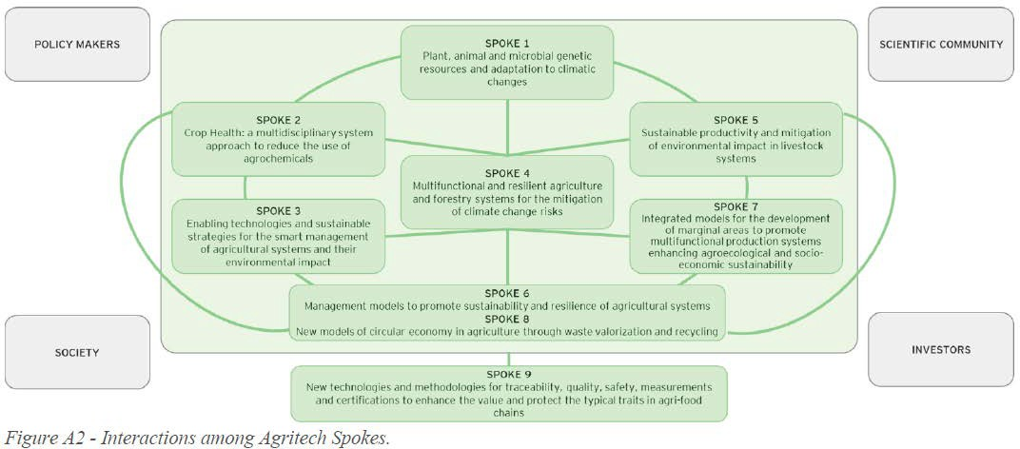

Briefly, plant and animal genetic materials and their associated microorganisms (Spoke 1) will be jointly investigated with Spoke 2 (plants) and Spoke 5 (animals) to study the mechanisms underlying the phenotypic traits that confer resistance to stress agents and promote growth and production levels. These improved genetic materials will be used in production protocols where cutting-edge KET (key enabling technologies) will be implemented to enhance sustainability and efficiency of the production processes in agricultural systems (Spoke 3), in multifunctional agriculture and forestry (Spoke 4) and in livestock systems (Spoke 5). The resilience of managed and natural ecosystems and their changes induced by agroecological and cultivation practices (Spoke 3 and 4) will be assessed using the methods developed by Spoke 2, to protect and enhance

